Delivery Portal Project

C4 Architecture Model

Version 1.0
Date – 24-12-2025

Revision History
Version | Date | Prepared By | Description of Change | Approved By
1.0 | 24-12-25 | Saurabh Rai

1. Executive Overview

1.1 Roles and Usage Patterns
- JC Admin – platform governance + full project control (companies, JC/client users, RBAC matrix, subscriptions/billing/manual payments, security/incident monitoring, tickets, pending requests, CMS/library/guidance, troubleshooting).
- JC PM – project execution + publish no platform governance no user invitations/seat allocation.
- Client Admin – client workspace owner invites and manages up to 5 Editors + 5 Viewers allocates seats and enforces client portal access controls manages client-level users and roles.
- Client Editor (5 seats) – upload, create/edit projects/folders/file, analytics, dashboards/reports, AI usage, publish where allowed no user admin.
- Client Viewer (5 seats) – view projects/folders/files and download where allowed view dashboards/reports AI read-only where applicable.

1.2 Key non-functional constraints
- On‑prem Keycloak integration for authentication (Keycloak setup out of scope).
- Access control + seat management requirements in client portal (SOW) including IP restrictions and concurrent login restrictions.
- Standardized errors, retries, DLQ handling and redrive/redraft semantics for long-running operations.
- Operational dashboards: queue errors, job failures, prompt failures, uploads in progress, AI activity logs.

2. C4 Level 1 – System Context
This diagram shows AITHOR boundary, users, and external dependencies.
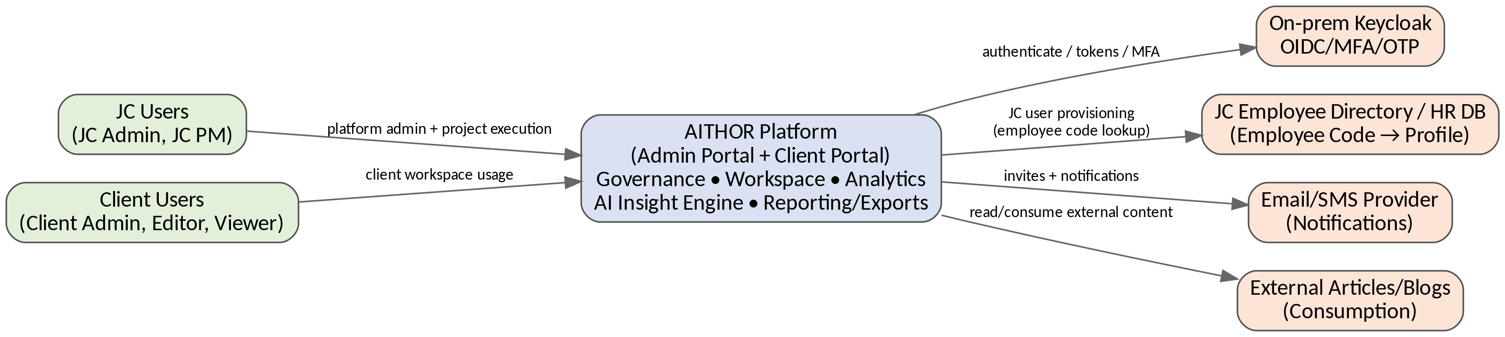
Figure 2-1. System Context (C4 Level 1)

2.1 External Dependencies
Dependency | Purpose | Notes
Keycloak (on‑prem) | token issuance, password reset flows | Integration only AITHOR does not implement its own credential store.
JC Employee Directory / HR DB | JC user provisioning via employee code lookup | MS2 fetches profile attributes on JC user creation/invite.
Email Provider | Invitations, notifications, alerts | Adapters in MS5 in-app notification always available.
External Articles/Blogs | User consumption/references | Role-gated access to AITHOR does not store external content.

3. C4 Level 2 – Container Architecture
This diagram includes all deployable units and all data stores described in the Data Model and design pack.
jjggjgj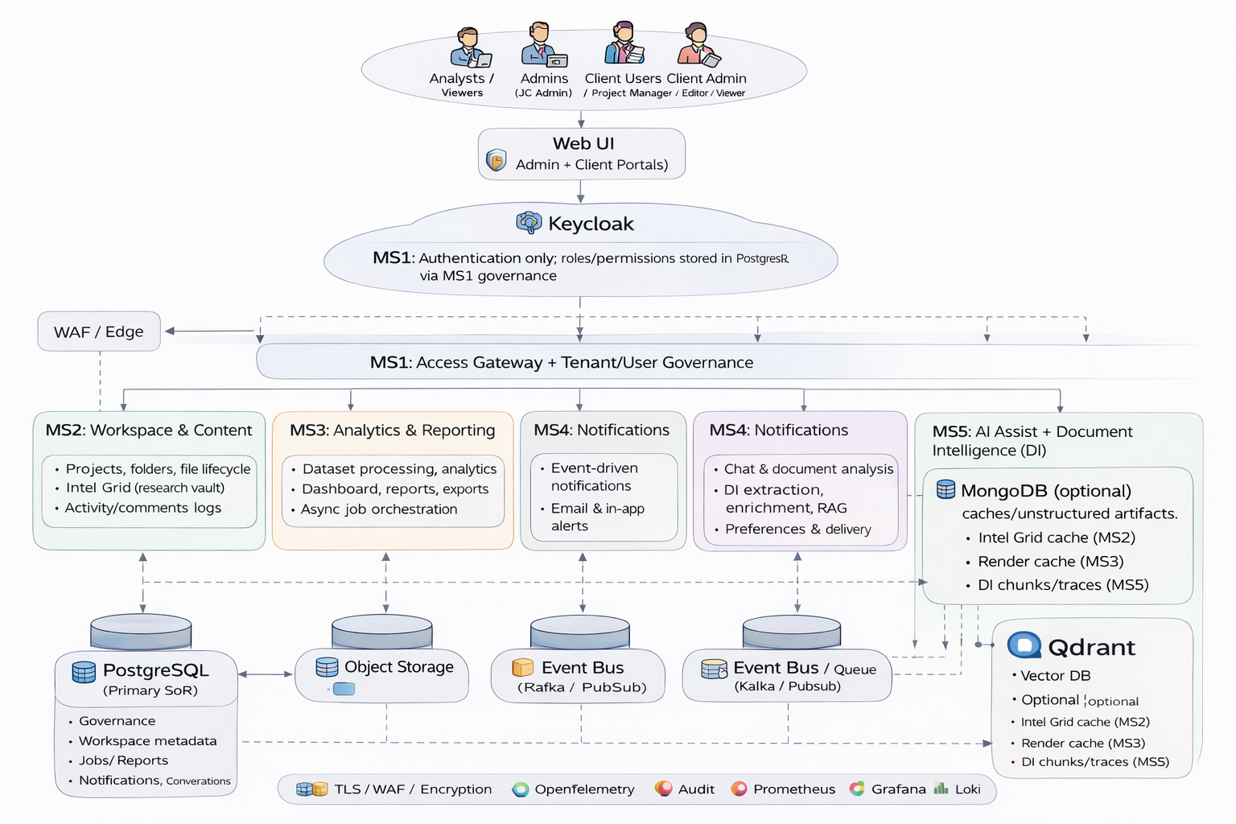

3.1 Container Responsibilities
Container | Responsibilities | Key Data / Integrations
UI (Admin Portal + Client Portal) | Tenant bootstrap and onboarding UI, invite acceptance UX, role-aware navigation, project workspace UI, dashboards/report studio UI, chat/insight UI, file upload/download using pre-signed URLs | Calls MS1 for all APIs. Upload/download goes directly to Object Storage using pre-signed URLs issued by MS2.
WAF / Edge | Perimeter protection, baseline rate limiting, TLS policy enforcement | Sends edge metrics/logs to observability stack.
MS1 (Merged) – Access Gateway + Tenant/User Governance | Auth facade and request validation, API versioning, tenancy guard, authorization enforcement (RBAC, entitlements, seat caps), session controls (expiry/forced logout), IP and concurrency controls (if enabled), idempotency and standardized errors, access logging and audit, tenant governance system-of-record (orgs, users, invites, lifecycle, roles, seats, subscription/billing gates, tickets/incidents if in scope), policy snapshot caching and invalidation  Authentication is handled by Keycloak (OIDC/SSO/MFA and token issuance). Authorization (roles, permissions, seat caps, subscription entitlements) is managed in the platform database and enforced centrally by MS1 before routing requests to downstream services. | Keycloak (OIDC/SSO/MFA), Directory/HR (AD/LDAP/employee attributes if applicable), PostgreSQL (governance + access logs + audit/outbox), Redis (policy cache if used), publishes domain events via Outbox → Event Bus, routes requests to MS2–MS5.
MS2 – Workspace & Content | Projects, folders, files, upload lifecycle, publishing and visibility rules, published project access, “My Projects” landing (cards/default folders/recent activity), activity and comments, Intel Grid metadata/caching, audit + outbox events | PostgreSQL (workspace metadata + audit/outbox), Object Storage (files/binaries via pre-signed URLs), MongoDB (Intel Grid cache), publishes events via Outbox → Event Bus (file_ready, content_updated, publish alerts).
MS3 – Analytics & Reporting | Dataset ingest, validation and schema inference, transform pipeline (clean/join/enrich), analytics computation (metrics/segments/trends/comparisons), dashboards and report composition, export generation (PDF/XLSX/CSV/PPT as applicable), job orchestration (async), render caching, job completion events | PostgreSQL (jobs/state/report metadata), Object Storage (exports and intermediates), MongoDB (render/export cache if used), Queue/Workers/DLQ for async processing, publishes events to Event Bus (job_completed, export_ready), integrates with MS2 for dataset/file references.
MS4 – Notifications Service | Event-driven notification orchestration, recipient resolution, channel selection, templates and localization, user/org notification preferences, delivery tracking and audit, retries and DLQ handling, adapters for email and in-app inbox (and optional SMS/Teams later) | Subscribes to Event Bus, PostgreSQL (preferences + delivery state), Redis optional (buffer/throttle), Email Provider (SMTP/API), In-app Inbox (UI notification center), Queue/DLQ for retry workflows (if implemented separately).
MS5 – AI Assist + Document Intelligence (DI) | Chat sessions and conversation context, intent classification and routing, agent orchestration (tool selection + fallback), DI extraction (text extraction, OCR if needed), chunking and metadata enrichment, embeddings generation, RAG retrieval, grounded answer generation via LLM, citations/explainability (sources/page refs/further reading), feedback capture and telemetry | Calls MS2 (content metadata and scoping) and optionally MS3 (analytics outputs), reads documents/exports from Object Storage, Vector DB (embeddings store), MongoDB (chunks/excerpts/traces), PostgreSQL (conversation metadata + feedback), subscribes to Event Bus (file_ready/content_updated/export_ready), integrates with LLM Provider (model API or on-prem runtime).

3.2 Container Diagram
The container diagram represents the complete AITHOR delivery portal platform as five microservices working together to support governed access, workspace operations, analytics, notifications, and AI-driven insights. All user actions enter via the Web UI and are enforced through MS1 before being routed to downstream services.

3.3 User personas
The platform supports multiple people. Roles determine what users can see and do across tenants, projects, and deliverables.
- JC Admin - Full platform administration and governance.
- JC Project Manager - Manages delivery/project operations and publishing workflows.
- Client Admin - Manages client org users, seats, and client-level governance.
- Client Editor - Creates/edits content, initiates analysis, builds reports.
- Client Reviewer - Review/approval workflows and controlled commenting.
- Client Viewer - Read-only consumption of projects, dashboards, and exports (AI read-only where applicable).

3.4 How requests flow end-to-end
At a high level, every request follows the same enforcement-first pattern:
1. A user performs an action in the Web UI (open project, upload file, run report, ask AI).
2. The Web UI calls MS1 (Access Gateway + Governance).
3. MS1 validates identity via Keycloak and enforces authorization and tenant policy (roles, seats, entitlements, security rules).
4. If allowed, MS1 routes the request to the appropriate downstream microservice (MS2-MS5).
5. If background processing is required (exports, ingestion, indexing), services publish events to the Event Bus for asynchronous handling.
6. The user receives status updates in the UI and, where relevant, via notifications.

3.5 Synchronous APIs vs asynchronous events
AITHOR uses two interaction modes:
- Synchronous API calls for real-time UI actions (navigation, metadata reads, quick updates).
- Asynchronous event-driven processing for long-running workloads (exports, ingestion, indexing, retries).
The Event Bus decouples services and prevents heavy processing from blocking user experience.

3.6 Data storage model
Different storage systems serve different data types while maintaining tenant isolation and auditability:
- PostgreSQL - system-of-record for governance, workspace metadata, job state, delivery state, and audit logs.
- Object Storage - large files and generated exports (PDF/PPT/XLSX/CSV as applicable).
- MongoDB - caches and unstructured artifacts (intel grid cache, extracted chunks/traces, render caches).
- Vector DB - embeddings for semantic retrieval (RAG).

3.7 Cross-cutting foundations
Security and operational controls apply consistently across services:
- Security: TLS, WAF, encryption, secret vault, and AI guardrails/PII handling where applicable.
- Observability: OpenTelemetry traces, Prometheus metrics, Grafana dashboards, Loki logs.

1.8 End-to-end flow
1. Client Admin invites users and configures roles/seats (governed in MS1).
2. Users authenticate via Keycloak, MS1 enforces policy on every request.
3. Editors create projects and upload files in the workspace (MS2) using secure file handling patterns.
4. Analytics jobs and exports run asynchronously (MS3), completion is published as events.
5. AI Assist indexes documents and answers questions with citations (MS5) based on authorized content.
6. Notifications (MS4) inform users when invites, exports, or key events are ready.

4. C4 Level 3 – Component Architecture

4.1 UI (Admin Portal + Client Portal)
- Bootstrap: load /me and /session/context enforce org/project selection fallback dropdown if context missing.
- Invitation onboarding: open invite link, validate token, create password handle invite expiry and resend prompts.
- Session behavior: handle session expiry and forced logout show secure re-auth experience.
- Pending Requests UX: show latest list if fetch fails, show last cached snapshot with “last updated” auto-refresh at intervals (e.g., 5 minutes) per sequence flows.
- My Project Page: tiles → project page → cards routing (Report Studio/Dataset Viewer/Media Viewer/internal tools) + default folders (Deliverables, Data Analysis, Media, Visualization, Appendix) + recent activity/comments.
- Role-aware modules: JC Admin governance modules JC PM project execution modules client admin/editor/viewer capability gating.
- In-app guidance + centralized library: render help content, guides, reusable assets role-gated to ensure correct visibility.

4.2 MS1 – API Gateway (Components)
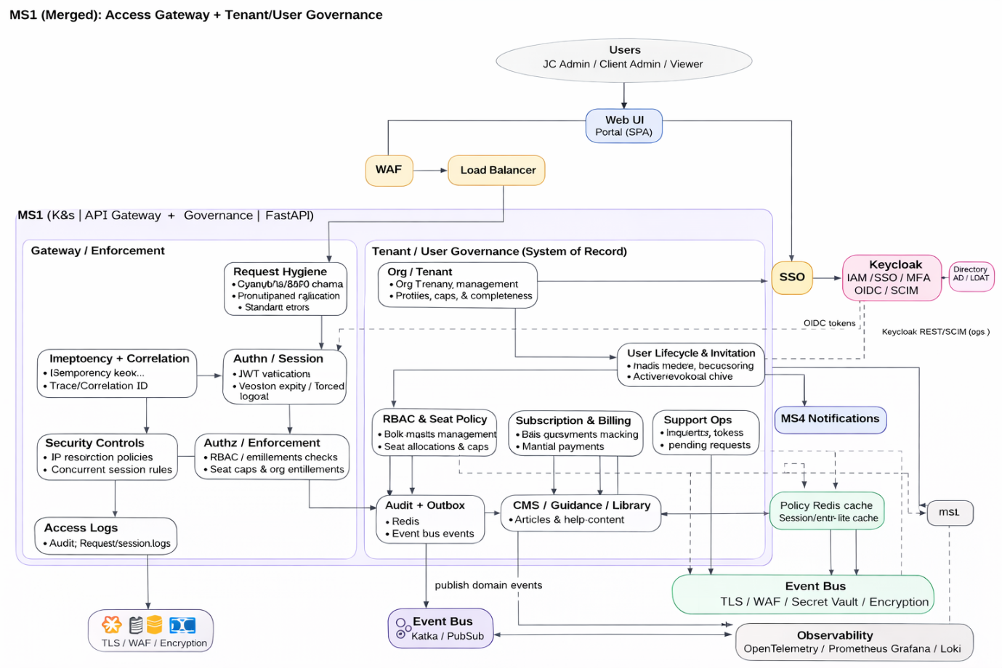

Purpose
MS1 is the single entry point for backend APIs. It integrates with Keycloak for authentication and enforces tenant policy, RBAC, entitlements, and session/security controls. It also owns governance workflows for tenants and users.

Core responsibilities
- Token/session validation (Keycloak integration).
- Authorization enforcement: RBAC, seat caps, entitlements, tenant isolation.
- Request hygiene and standardized error responses.
- Security controls (IP/session constraints where configured).
- Audit logging and trace context for all requests.
- Tenant and user governance: org profile, invites, lifecycle, policy snapshots.

Typical flows

Flow A: Normal portal usage
1. User action is initiated in Web UI.
2. MS1 validates token and enforces policy.
3. MS1 routes the request to the appropriate downstream service.
4. MS1 records audit context.

Flow B: Invite user
1. Admin initiates invite in UI.
2. MS1 checks permissions and seat caps.
3. MS1 creates invite/lifecycle record.
4. MS1 publishes an event for notification delivery.

Flow C: Policy update (RBAC/Seats/Entitlements)
1. Admin updates role matrix or seat allocations.
2. MS1 persists policy changes.
3. Policy cache is invalidated so enforcement updates immediately.

4.3 MS2 – Workspace & Content
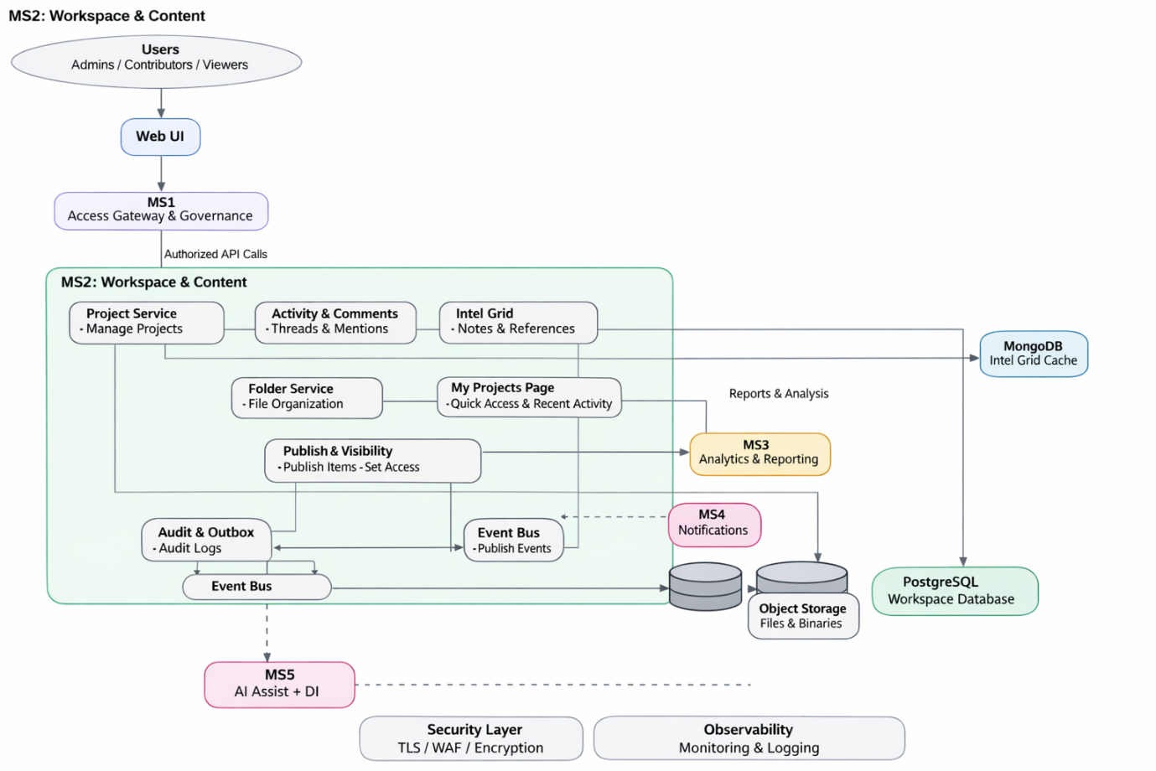

Purpose
MS2 is the workspace domain. It manages projects, folders, file lifecycle, publish/visibility rules, activity/comments, and intel grid artifacts. MS2 assumes requests are already authorized by MS1.

Core responsibilities
- Project lifecycle and metadata (create/update/list).
- Folder structure and default workspace organization.
- File lifecycle: upload/download controls and audit.
- Publish and visibility rules (audience gating).
- Activity and comments for collaboration.
- Intel grid notes/references and caching.
- Audit/outbox events for reliable downstream processing triggers.
- Per-user storage quota policy
- Maintain default quota and user-specific overrides (increase/decrease quota for a specific user).
- Store quota policy + audit trail (who changed, when, reason).
- Compute and expose effective quota for UI and enforcement.
- Storage usage + enforcement
- Track used_bytes and reserved_bytes per user.
- Enforce used + reserved + expected_upload_size <= effective_quota at upload initiation.

Typical flows

Flow A: Browse projects and content
1. UI calls MS1, MS1 routes to MS2.
2. MS2 returns project list, folder tree, and file metadata.
3. UI renders My Projects and recent activity views.

Flow B: Upload file (secure pattern)
1. UI requests upload initiation via MS1 to MS2.
2. MS2 returns a pre-signed upload URL.
3. UI uploads file directly to Object Storage.
4. MS2 records file metadata and status.
5. MS2 publishes content_updated/file_ready event.

Flow C: Publish content
1. User triggers publish via UI.
2. MS2 updates publish status and audience rules.
3. MS2 emits events to downstream services.

Flow D: Manage user storage quota
1. Admin UI calls MS1; MS1 routes to MS2.
2. MS2 validates caller has admin permission (MS1 already authorized; MS2 can still enforce “admin-only” scope).
3. MS2 updates user_quota_override_bytes for the target user (or clears it to revert to default).
4. MS2 emits quota_updated event (optional) for analytics/audit downstream.

4.4 MS3 – Analytics & Reporting
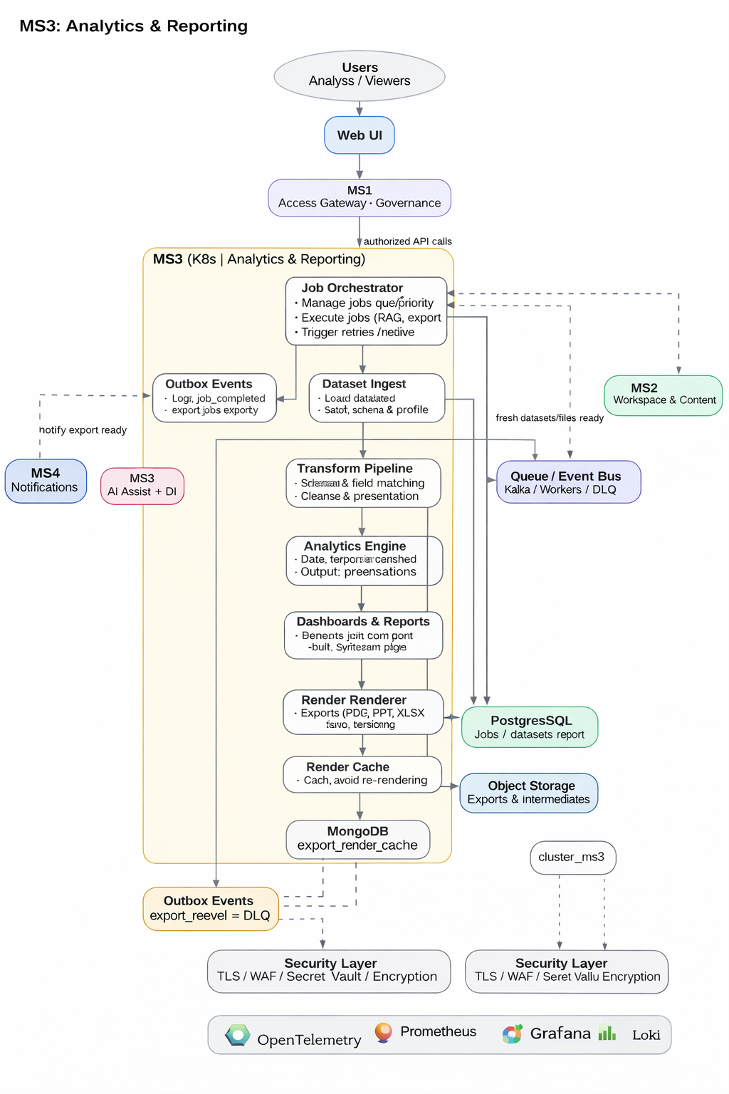

Purpose
MS3 is the analytics factory. It ingests datasets, runs transformations and calculations, composes dashboards/reports, and generates exports. Long-running work is executed asynchronously using queue/worker patterns.

Core responsibilities
- Job orchestration: create jobs, track states, handle retries.
- Dataset ingest: validation, profiling, schema inference.
- Transform pipeline: clean/join/enrich, persist results.
- Analytics computation: metrics, segmentation, trends, comparisons.
- Dashboards and reports: compose visuals and maintain versions.
- Export rendering: generate and store deliverables.
- Render caching to avoid repeated expensive re-renders.
- Outbox events: job_completed/export_ready.

Typical flows

Flow A: Run analysis / request export
1. UI calls MS1, MS1 routes to MS3.
2. MS3 creates a job record and returns a jobId.
3. Workers execute ingest-transform-analytics pipeline.
4. MS3 stores outputs and updates job state.
5. MS3 publishes export_ready/job_completed event.

Flow B: Datasets ingest and transform
1. MS3 fetches dataset references from MS2.
2. MS3 loads data via object URLs and validates inputs.
3. Transform pipeline produces curated results.
4. Analytics engine computes deterministic outputs.

4.5 MS4 – Notifications
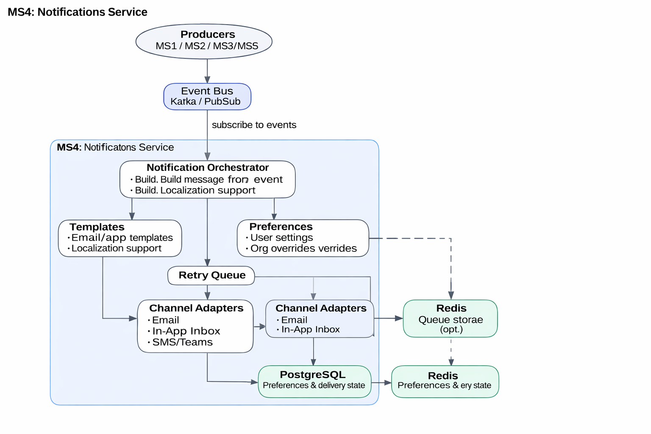

Purpose
MS4 is the platform's event-driven notification delivery service. It consumes events (invites, export ready, publish alerts) and delivers email and in-app notifications based on user and org preferences.

Core responsibilities
- Subscribe to events from the Event Bus.
- Notification orchestration: recipients, channels, templates.
- Preference evaluation: user opt-in/out and org overrides.
- Channel adapters: email provider and in-app inbox.
- Retries and dead-letter queue (DLQ) for resilient delivery.
- Delivery state persistence and auditing (queued/sent/failed/read).

Typical flows

Flow A: Invitation notification
1. MS1 publishes invite_created event.
2. MS4 selects template and recipients.
3. MS4 checks delivery preferences.
4. MS4 sends via email/in-app adapters and records status.

Flow B: Export ready notification
1. MS3 publishes export_ready event.
2. MS4 notifies the requesting user.
3. MS4 records delivery status and handles retries if needed.

Notes
MS4 is decoupled from core workflows so notification delivery and provider failures do not impact workspace, governance, or analytics operations.

4.6 MS5 – AI Assist + Document Intelligence (Components)
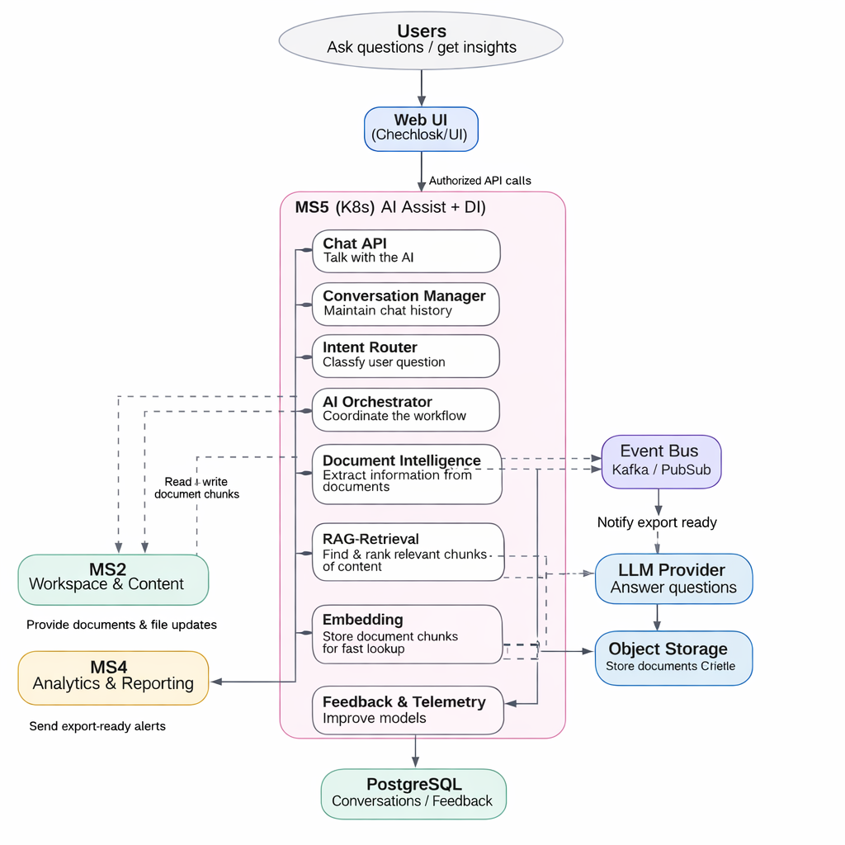

Purpose
MS5 provides AI-driven insights over governed platform content. It supports multi-turn chat, document text extraction and chunking, embedding-based retrieval (RAG), citations/explainability, and feedback/telemetry.

Core responsibilities
- Chat handling and multi-turn conversation context.
- Intent routing to select correct tool path (retrieval vs analytics vs summarization).
- Agent orchestration with context scoping and safety boundaries.
- Document Intelligence: text extraction (OCR where needed) and metadata capture.
- Chunking and embeddings for semantic retrieval.
- RAG retrieval to ground answers in source content.
- Citations and explainability (sources, page references).
- Feedback and telemetry for monitoring and continuous improvement.

Typical flows

Flow A: Ask a question about project content
1. UI sends question via MS1 to MS5.
2. MS5 loads conversation context and classifies intent.
3. MS5 retrieves relevant chunks from Vector DB.
4. LLM produces grounded answer using retrieved context.
5. MS5 returns answer with citations and stores conversation metadata.

Flow B: New document upload triggers DI indexing
1. MS2 publishes file_ready/content_updated.
2. MS5 consumes event and extracts text.
3. MS5 chunks content and generates embeddings.
4. Embeddings are stored in Vector DB for future retrieval.

5. Cross-Cutting Architecture (Strict)

5.1 Identity Lifecycle (Invite, Password, Sessions, Audit)
- Invite-based onboarding for non-JC Admin: invite token validation, password creation, invite expiry, resend workflows.
- Password reset/forgot-password flows are executed via Keycloak UI links to Keycloak recovery platform records user status and audit events.
- Session lifecycle: expiry and forced logout supported gateway and UI handle re-auth logout events are audited.
- Login/logout auditing and security telemetry are stored in access/audit logs for support and incident monitoring.
- Lock rules: 3 failed attempts temporary lock (3 minutes), 5 failed permanent lock for non-JC Admin JC Admin exempt (as per design pack).

5.2 Authorization and Subscription Enforcement
- RBAC matrix (feature/sub-feature perms) in MS2 is the policy source-of-truth MS1 enforces at runtime.
- Subscription entitlements and seat allocation control availability denials return standardized ENTITLEMENT_DENIED/PERMISSION_DENIED errors.
- Client admin seat caps enforced at invite/activation and runtime for concurrent login policies.

5.3 Data Stores and Consistency
- PostgreSQL is the transactional system-of-record: governance, workspace metadata, jobs, audit logs, outbox, access logs, notification preferences.
- MongoDB stores unstructured caches and AI artifacts: file_text_extractions, vector_chunks, intel_grid_cache, export_render_cache.
- Object storage stores binaries (uploads and exports) accessed via presigned URLs metadata references stored in PG.
- Vector store holds embeddings for semantic retrieval MS5 is owner of embedding/query flows.

5.4 Events, DLQ, and Redrive/Redraft
- Outbox pattern publishes domain events from MS2–MS5 into the event bus with tenant context.
- DLQ captures poison messages redrive is controlled redraft creates new artifacts/jobs with new IDs for traceability.
- Operational dashboards surface queue errors, job failures, and prompt failures to enable support workflows.

5.5 Error Handling Standard
- All services return standardized error envelopes gateway normalizes dependency errors.
- Idempotency keys required for retryable writes async jobs return 202 + jobId and deterministic job states.

6. Deployment, Operations, and NFRs

6.1 Monitoring & Alerting
- Central dashboards for: queue depth/errors, job failures, prompt failures, upload failures/in-progress, security alerts, availability/latency SLOs.
- Alerting policies for: elevated 5xx rates, Keycloak unavailability, broker/queue DLQ growth, DB saturation, object-store failures.

6.2 Patch, Upgrade, and Release Governance
- CI/CD pipelines enforce build/test/security scans and contract tests releases promoted via environment gates.
- Patch & upgrade strategy: rolling updates for stateless services database migration discipline rollback plans.

6.3 Backup/DR
- Backups for PG/Mongo and object storage restore drills and documented runbooks.
- RPO/RTO targets to be finalized with stakeholders.

